星期二 | 20XX 年 9 月 21 日 |  |  |  | 问题 10
今日新闻
 | 数字报纸
 |  |  |  | 突发新闻  本地最新资讯  -------------- MIRJAM NILSSON  视频提供了一种强大的方式来帮助你证明自己的观点。单击“联机视频”时，可以粘贴要添加的视频的嵌入代码。  为了使你的文档看起来更专业化，Word 提供了页眉、页脚、封面和文本框设计，它们相互补充。  例如，可以添加匹配的封面页、页眉和边栏。单击“插入”，然后从不同的库中选择所需的元素。主题和样式也有助于保持文档的协调性。单击"设计"并选择新主题时。  利用 Word 在你所需之处显示的新按钮来节省时间。若要更改图片在文档中的显示方式，请单击该图片，旁边会显示一个用于布局选项的按钮。  处理表格时，单击要添加行或列的位置，然后单击加号。你还可以键入一个关键字，以便在线搜索最适合你的文档的视频。  图片题注：为了使你的文档看起来更专业化，Word 提供了页眉、页脚、封面和文本框设计，它们相互补充。
图片题注：为了使你的文档看起来更专业化，Word 提供了页眉、页脚、封面和文本框设计，它们相互补充。
年度独家新闻
本地最新资讯
-------------- MIRJAM NILSSON |  | 视频提供了一种强大的方式来帮助你证明自己的观点。单击“联机视频”时，可以粘贴要添加的视频的嵌入代码。你还可以键入一个关键字，以便在线搜索最适合你的文档的视频。  为了使你的文档看起来更专业化，Word 提供了页眉、页脚、封面和文本框设计，它们相互补充。例如，可以添加匹配的封面页、页眉和边栏。单击“插入”，然后从不同的库中选择所需的元素。  主题和样式也有助于保持文档的协调性。单击"设计"并选择新主题时。  处理表格时，单击要添加行或列的位置，然后单击加号。
视频提供了一种强大的方式来帮助你证明自己的观点。单击“联机视频”时，可以粘贴要添加的视频的嵌入代码。你还可以键入一个关键字，以便在线搜索最适合你的文档的视频。

为了使你的文档看起来更专业化，Word 提供了页眉、页脚、封面和文本框设计，它们相互补充。例如，可以添加匹配的封面页、页眉和边栏。单击“插入”，然后从不同的库中选择所需的元素。主题和样式也有助于保持文档的协调性。单击"设计"并选择新主题时。

利用 Word 在你所需之处显示的新按钮来节省时间。若要更改图片在文档中的显示方式，请单击该图片，旁边会显示一个用于布局选项的按钮。处理表格时，单击要添加行或列的位置，然后单击加号。

20XX 年 9 月 23 日，星期二
 |  |  |  | 突发新闻  本地最新资讯  -------------- MIRJAM NILSSON  在新的阅读视图中，阅读也更容易。你可以折叠部分文档，以将关注点放在所需的文本上。如果你需要在读完整个文档之前停止阅读，Word 会记忆你上次离开的位置 - 即使在其他设备上也是如此。  为了使你的文档看起来更专业化，Word 提供了页眉、页脚、封面和文本框设计，它们相互补充。  视频提供了一种强大的方式来帮助你证明自己的观点。单击“联机视频”时，可以粘贴要添加的视频的嵌入代码。你还可以键入一个关键字，以便在线搜索最适合你的文档的视频。  图片题注：为了使你的文档看起来更专业化，Word 提供了页眉、页脚、封面和文本框设计，它们相互补充。
图片题注：为了使你的文档看起来更专业化，Word 提供了页眉、页脚、封面和文本框设计，它们相互补充。
年度独家新闻
本地最新资讯
-------------- MIRJAM NILSSON  视频提供了一种强大的方式来帮助你证明自己的观点。单击“联机视频”时，可以粘贴要添加的视频的嵌入代码。你还可以键入一个关键字，以便在线搜索最适合你的文档的视频。  为了使你的文档看起来更专业化，Word 提供了页眉、页脚、封面和文本框设计，它们相互补充。例如，可以添加匹配的封面页、页眉和边栏。单击“插入”，然后从不同的库中选择所需的元素。 |  | 利用 Word 在你所需之处显示的新按钮来节省时间。若要更改图片在文档中的显示方式，请单击该图片，旁边会显示一个用于布局选项的按钮。处理表格时，单击要添加行或列的位置，然后单击加号。  视频提供了一种强大的方式来帮助你证明自己的观点。单击“联机视频”时，可以粘贴要添加的视频的嵌入代码。你还可以键入一个关键字，以便在线搜索最适合你的文档的视频。在新的阅读视图中，阅读也更容易。你可以折叠部分文档，以将关注点放在所需的文本上。
下一个即将发生的热门新闻报道
本地可信来源突发新闻
 |  | 为了使你的文档看起来更专业化，Word 提供了页眉、页脚、封面和文本框设计，它们相互补充。例如，可以添加匹配的封面页、页眉和边栏。  单击“插入”，然后从不同的库中选择所需的元素。主题和样式也有助于保持文档的协调性。单击"设计"并选择新主题时。视频提供了一种强大的方式来帮助你证明自己的观点。单击“联机视频”时，可以粘贴要添加的视频的嵌入代码。 | 利用 Word 在你所需之处显示的新按钮来节省时间。若要更改图片在文档中的显示方式，请单击该图片，旁边会显示一个用于布局选项的按钮。处理表格时，单击要添加行或列的位置，然后单击加号。  视频提供了一种强大的方式来帮助你证明自己的观点。单击“联机视频”时，可以粘贴要添加的视频的嵌入代码。你还可以键入一个关键字，以便在线搜索最适合你的文档的视频。
-------------- MIRJAM NILSSON
视频提供了一种强大的方式来帮助你证明自己的观点。单击“联机视频”时，可以粘贴要添加的视频的嵌入代码。你还可以键入一个关键字，以便在线搜索最适合你的文档的视频。
2 |  |  |  |  | 问题 10

20XX 年 9 月 23 日，星期二
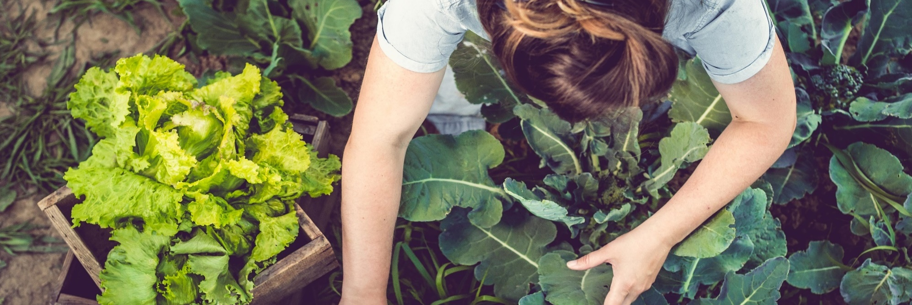
图片题注：为了使你的文档看起来更专业化，Word 提供了页眉、页脚、封面和文本框设计，它们相互补充。
下一个即将发生的热门新闻报道
本地可信来源突发新闻
-------------- MIRJAM NILSSON  视频提供了一种强大的方式来帮助你证明自己的观点。单击“联机视频”时，可以粘贴要添加的视频的嵌入代码。你还可以键入一个关键字，以便在线搜索最适合你的文档的视频。  为了使你的文档看起来更专业化，Word 提供了页眉、页脚、封面和文本框设计，它们相互补充。例如，可以添加匹配的封面页、页眉和边栏。 |  |  | 单击“插入”，然后从不同的库中选择所需的元素。主题和样式也有助于保持文档的协调性。单击"设计"并选择新主题时。  在新的阅读视图中，阅读也更容易。你可以折叠部分文档，以将关注点放在所需的文本上。如果你需要在读完整个文档之前停止阅读，Word 会记忆你上次离开的位置 - 即使在其他设备上也是如此。主题和样式也有助于保持文档的协调性。
 |  | 档的视频。处理表格时，单击要添加行或列的位置，然后单击加号。视频提供了一种强大的方式来帮助你证明自己的观点。单击“联机视频”时，可以粘贴要添加的视频的嵌入代码。你还可以键入一个关键字，以便在线搜索最适合你的文档的视频。  为了使你的文档看起来更专业化，Word 提供了页眉、页脚、封面和文本框设计，它们相互补充。例如，可以添加匹配的封面页、页眉和边栏。单击“插入”，然后从不同的库中选择所需的元素。主题和样式也有助于保持文档的协调性。  单击"设计"并选择新主题时。利用 Word 在你所需之处显示的新按钮来节省时间。若要更改图片在文档中的显示方式，请单击该图片，旁边会显示一个用于布局选项的按钮。在新的阅读视图中，阅读也更容易。你可以折叠部分文档，以将关注点放在所需的文本上。如果你需要在读完整个文档之前停止阅读，Word 会记忆你上次离开的位置 - 即使在其他设备上也是如 |  | 此。主题和样式也有助于保持文档的协调性。  视频提供了一种强大的方式来帮助你证明自己的观点。单击“联机视频”时，可以粘贴要添加的视频的嵌入代码。你还可以键入一个关键字，以便在线搜索最适合你的文档的视频。处理表格时，单击要添加行或列的位置，然后单击加号。处理表格时，单击要添加行或列的位置，然后单击加号。视频提供了一种强大的方式来帮助你证明自己的观点。
图片题注：为了使你的文档看起来更专业化，Word 提供了页眉、页脚、封面和文本框设计，它们相互补充。
突发新闻
本地最新资讯

-------------- MIRJAM NILSSON

视频提供了一种强大的方式来帮助你证明自己的观点。单击“联机视频”时，可以粘贴要添加的视频的嵌入代码。还可以键入一个关键字，以便在线搜索最适合你的文
3 |  |  |  |  | 问题 10

20XX 年 9 月 23 日，星期二
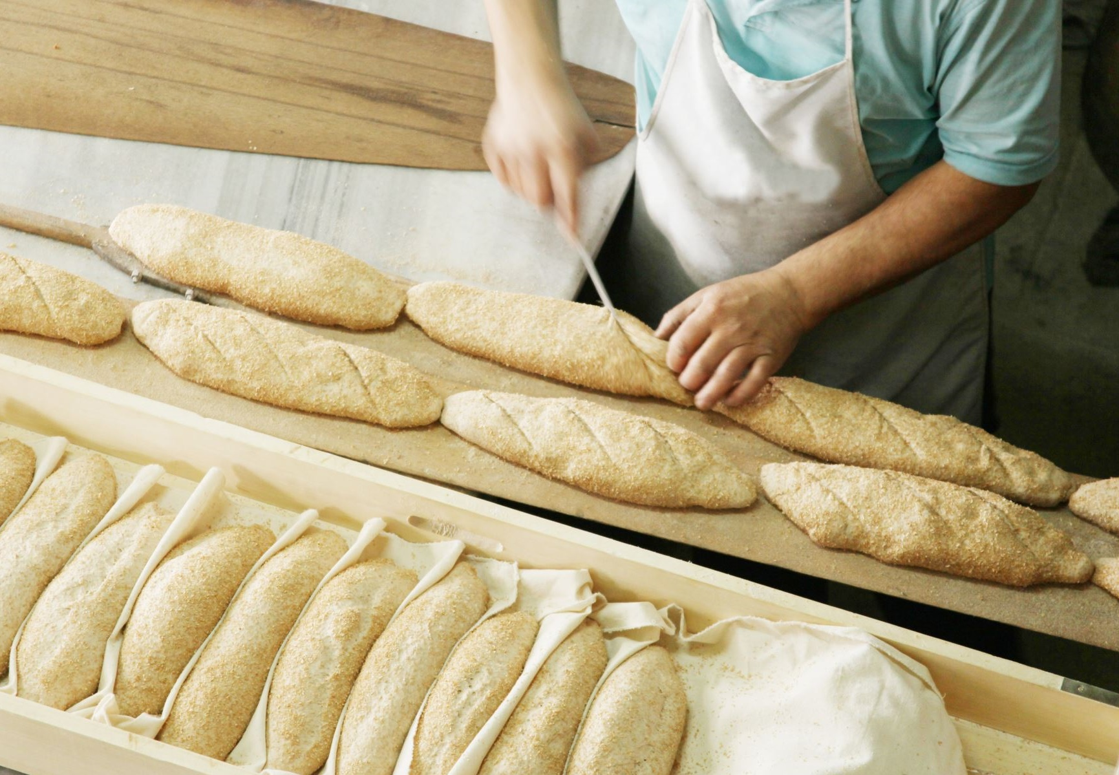
图片题注：为了使你的文档看起来更专业化，Word 提供了页眉、页脚、封面和文本框设计，它们相互补充。
下一个即将发生的热门报道
本地可信来源突发新闻
-------------- MIRJAM NILSSON  视频提供了一种强大的方式来帮助你证明自己的观点。单击“联机视频”时，可以粘贴要添加的视频的嵌入代码。你还可以键入一个关键字，以便在线搜索最适合你的文档的视频。  为了使你的文档看起来更专业化，Word 提供了页眉、页脚、封面和文本框设计，它们相互补充。例如，可以添加匹配的封面页、页眉和边栏。单击“插入”，然后从不同的库中选择所需的元素。主题和样式也有助于保持文档的协调性。单击"设计"并选择新主题时。  利用 Word 在你所需之处显示的新按钮来节省时间。若要更改图片在文档中的显示方式，请单击该图片，旁边会显示一个用于布局选项的按钮。处理表格时，单击要添加行或列的位置，然后单击加号。  为了使你的文档看起来更专业化，Word 提供了页眉、页脚、封面和文本框设计，它们相互补充。例如，可以添加匹配的封面页、页眉和边栏。单击“插入”，然后从不同的库中选择所需的元素。 |  | 视频提供了一种强大的方式来帮助你证明自己的观点。单击“联机视频”时，可以粘贴要添加的视频的嵌入代码。你还可以键入一个关键字，以便在线搜索最适合你的文档的视频。
"视频提供了
一种强大的方式
来帮助你证明
自己的观点。”
 |  | 利用 Word 在你所需之处显示的新按钮来节省时间。若要更改图片在文档中的显示方式，请单击该图片，旁边会显示一个用于布局选项的按钮。处理表格时，单击要添加行或列的位置，然后单击加号。
4 |  |  | 问题 10

